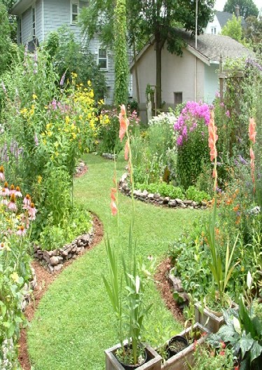  What will you learn?  Week by week you will learn everything necessary to create a wildlife habitat specific to your property. The course begins with a personalized soil property evaluation and then explores how to attract pollinators like bees, insects, birds and bats. From there you will learn how to understand plant selection and manage invasive species. You will also identify how to attract other wildlife to your backyard, including small mammals like rabbits; a variety of birds; reptiles, such as turtles, and amphibians like frogs and toads.  Register Today!  You must bring a laptop/tablet to each session  Name: _______________________________________  Address: _____________________________________  City: ________________________ Zip: ____________  Phone: _______________________________________  Can we text you at this number? Yes No  Email: _______________________________________  Please enclose check for $75.00 and mail to:  oakland conservation district  Deer Lake Center  7150 Dixie Highway Suite 2  Clarkston, MI 48346 |  |  | About Us  The Oakland Conservation District is a federally mandated public entity designed to promote sound soil and water conservation practices and provide natural resource information and technical assistance to Oakland County residents, municipalities, and governments.  Contact Us:  Phone: 248-922-7822  Email: OaklandConservation@gmail.com  Web: OaklandConservationDistrict.org  Sponsored by:  classes meet from  6:15 – 7:45 p.m.  at the  waterford township library  5168 civic center dr. 48329 |  | WORKSHOP  MARCH 7, 2022  CERTIFICATION PROGRAM  Design a custom wildlife habitat for your backyard. This four-part workshop is perfect for all experience levels. Big yard or small, every habitat counts.  FOUR-PART WORKSHOP  March 7, 14, 21, 28  ONLY $75  Includes a binder of class information

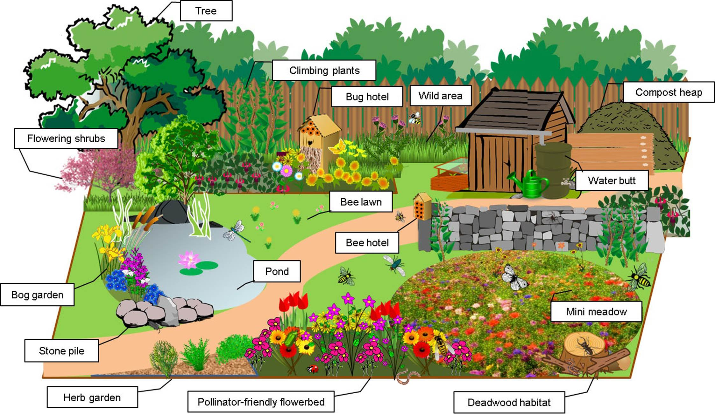  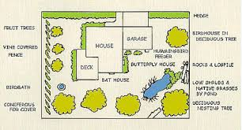  Whether you have 10 square feet or 10 acres you can create a wildlife habitat, shelter and nutrition for your furry and feathered friends, as well as insects and amphibians.  You must bring a computer/tablet  to each session.  Plans certified by the Oakland Conservation District P: 248.922.7822 www.OaklandConservationDistrict.org |  |  | BACKYARD HABITAT COURSE  A laptop/tablet is required  Session 1: Your Property – Soil  Web Soil Survey  Monday – March 7, 2022  Session 2: Pollinator Habitats  Butterflies, Birds, Bats & Insects  Monday – March 14, 2022  Session 3: Mammals, Amphibians &  Reptile Habitats  Develop Plan Outline  Monday — March 21, 2022  Session 4: Managing Invasive Plants  Michigan Natural Features  Inventory  Monday – March 28, 2022  Program Fee: $75  Includes Certification Sign for your  Property  Class meets from  6:15 – 7:45 p.m.  WATERFORD TOWNSHIP LIBRARY  5168 Civic Center Dr. 48329  For more information contact instructor  Jay Blair (810) 869-1311 |  | 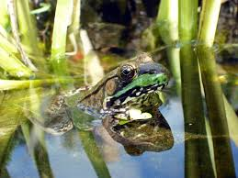  2018 BACKYARD HABITAT PROGRAM  For property owners who would like to learn how to develop a backyard habitat for wildlife. The Oakland Conservation District, is a locally led organization of state government with guidance from USDA. The Oakland Conservation District has a variety of resources to aide local property owners in developing their backyard habitat.  To understand the best backyard habitat one needs to have knowledge of their property’s soil. From this one can then identify the plants that will enable the proper habitat for the wildlife you want in your back yard. You may find by attending this program there are other wildlife you would like to attract to your back yard.  Once your plan is approved by the Oakland Conservation District, you will receive a sign promoting your successful certification, which is good for five years.  Proudly post your weatherproof plaque where others can see your commitment to wildlife conservation! Doing so helps educate and encouraging others to do the same.

